UNITY TERRAIN CREATION

TASK-1

DONE BY:

MOULISH G A

SCREEN SHOTS IN FOUR ANGLES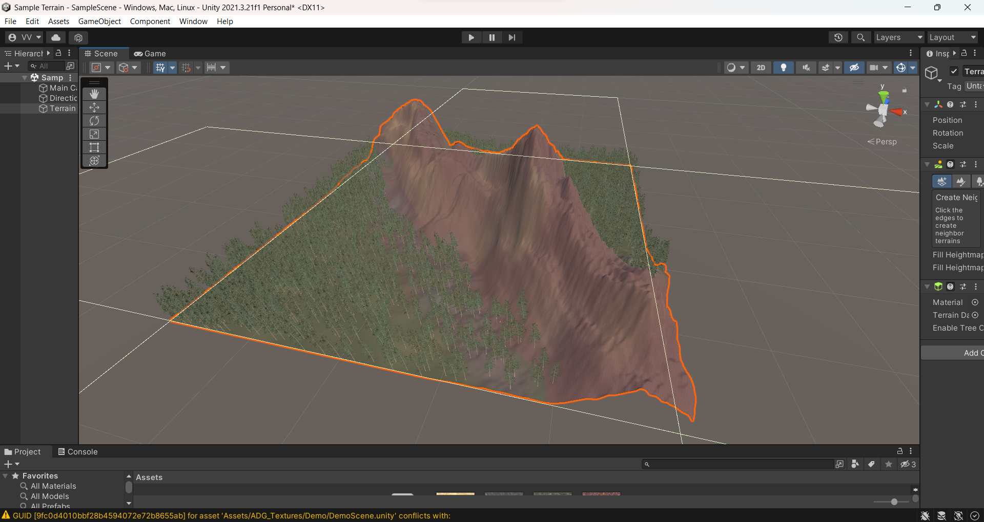

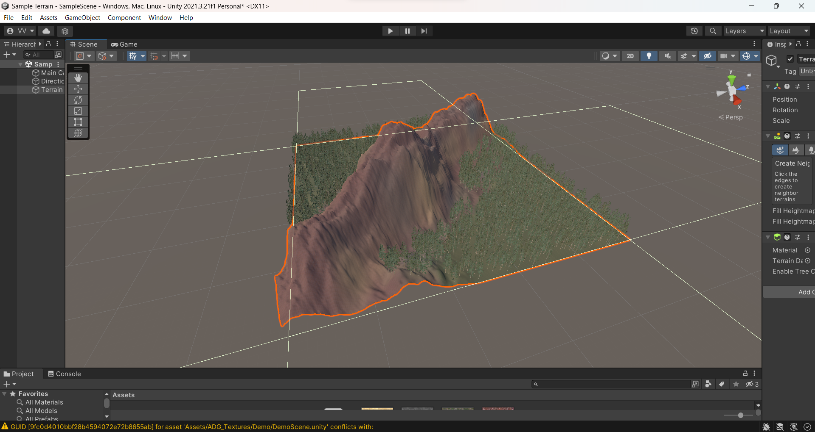

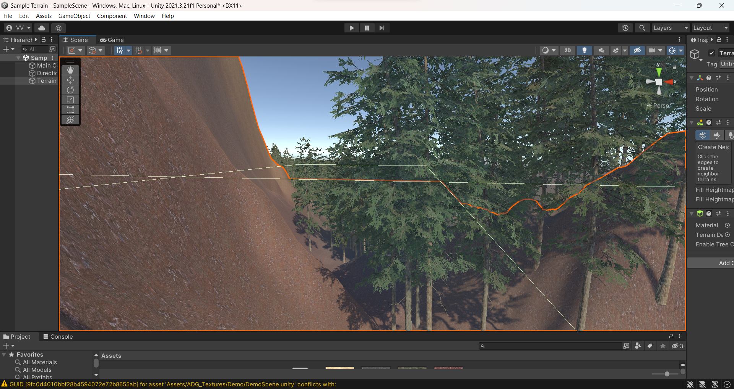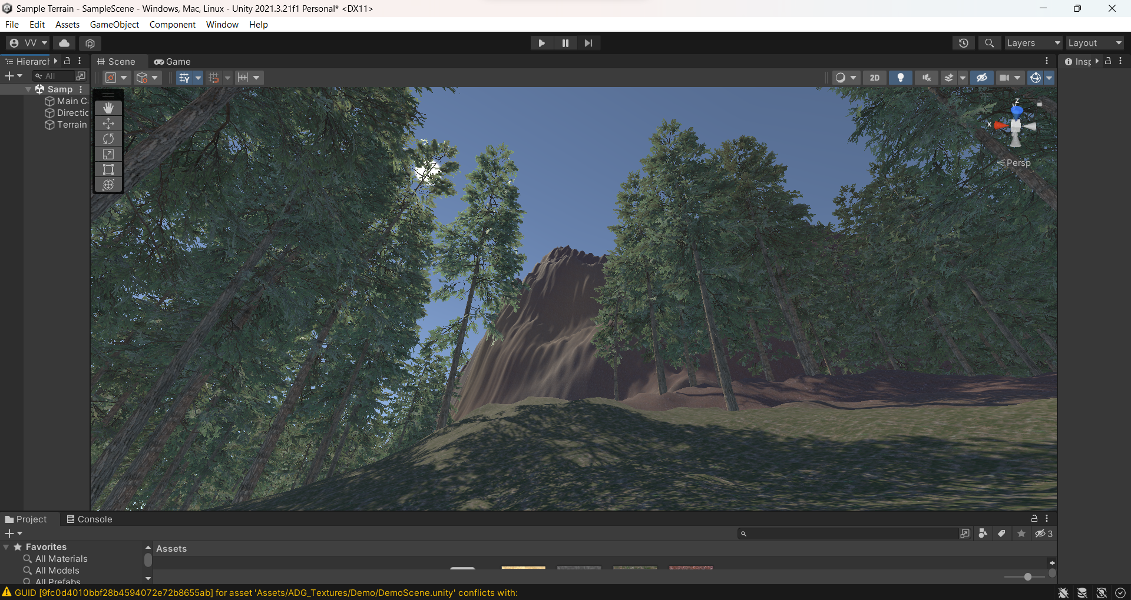

THE LINKS FOR ASSETS USED

https://assetstore.unity.com/packages/2d/textures-materials/nature/grass-and-flowers-pack-1-17100

https://assetstore.unity.com/packages/3d/vegetation/trees/conifers-botd-142076

https://assetstore.unity.com/packages/2d/textures-materials/floors/outdoor-ground-textures-12555